

**mergers and acquisitions**

Introduction to Business

Assignment # 2

Submitted To: Sadaf Amin  
Submitted By: Usama Sarwar | FA17-BCS-**090**

March 8, 2018





C O M S A T S I n s t I t u t e o f I n f o r m a t I o n T e c h n o l o g y

Virtual Campus

**MERGER & ACQUISITION**

# Merger

* A transaction where two firms agree to integrate their operations on a relatively co-equal basis because they have resources and capabilities that together may create a stronger competitive advantage.
* The combining of two or more companies, generally by offering the stockholders of one company securities in the acquiring company in exchange for the surrender of their stock
* Example: Company A+ Company B= Company C.

# Acquisition

* A transaction where one firm buys another firm with the intent of more effectively using a core competence by making the acquired firm a subsidiary within its portfolio of business
* It also known as a takeover or a buyout
* It is the buying of one company by another.
* In acquisition two companies are combine together to form a new company altogether.
* Example: Company A+ Company B= *Company A.*

# MERGER vs ACQUISITION

|  |  |
| --- | --- |
| **MERGER** | **ACQUISITION** |
| Merging of two organization in to one. | Buying one organization by another. |
| It is the mutual decision. | It can be friendly takeover or hostile takeover. |
| Merger is expensive than acquisition (higher legal cost). | Acquisition is less expensive than merger. |
| Through merger shareholders can increase their net worth. | Buyers can’t raise their enough capital. |
| It is time consuming and the company has to maintain so much legal issues. | It is faster and easier transaction. |
| Dilution of ownership occurs in merger. | The acquirer doesn’t experience the dilution of ownership. |

# MERGER: WHY & WHY NOT

##### Why:

* Increase Market Share.
* Economies of scale
* Profit for Research and development.
* Benefits on account of tax shields like carried forward losses or unclaimed depreciation.
* Reduction of competition.

##### Why not:

* Clash of corporate cultures
* Increased business complexity
* Employees may be resistant to change

# ACQUISITION: WHY & WHY NOT

##### Why:

* Increased market share.
* Increased speed to market
* Lower risk comparing to develop new products.
* Increased diversification
* Avoid excessive competition

##### Why not:

* Inadequate valuation of target.
* Inability to achieve synergy.
* Finance by taking huge debt.

# Example

# **Microsoft to acquire LinkedIn**

June 13, 2016 | Microsoft News Center

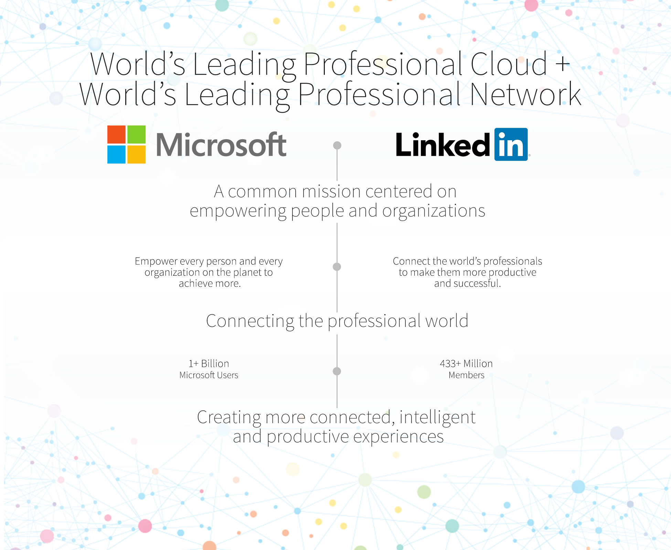

Microsoft Corp. (Nasdaq: MSFT) and LinkedIn Corporation (NYSE: LNKD) on Monday announced they have entered into a definitive agreement under which Microsoft will acquire LinkedIn for $196 per share in an all-cash transaction valued at $26.2 billion, inclusive of LinkedIn’s net cash. LinkedIn will retain its distinct brand, culture and independence. Jeff Weiner will remain CEO of LinkedIn, reporting to Satya Nadella, CEO of Microsoft. Reid Hoffman, chairman of the board, co-founder and controlling shareholder of LinkedIn, and Weiner both fully support this transaction. The transaction is expected to close this calendar year.

LinkedIn is the world’s largest and most valuable professional network and continues to build a strong and growing business. Over the past year, the company has launched a new version of its mobile app that has led to increased member engagement; enhanced the LinkedIn newsfeed to deliver better business insights; acquired a leading online learning platform called Lynda.com to enter a new market; and rolled out a new version of its Recruiter product to its enterprise customers. These innovations have resulted in increased membership, engagement and financial results, specifically:

* 19 percent growth year over year (YOY) to more than 433 million members worldwide
* 9 percent growth YOY to more than 105 million unique visiting members per month
* 49 percent growth YOY to 60 percent mobile usage
* 34 percent growth YOY to more than 45 billion quarterly member page views
* 101 percent growth YOY to more than 7 million active job listings

“The LinkedIn team has grown a fantastic business centered on connecting the world’s professionals,” Nadella said. “Together we can accelerate the growth of LinkedIn, as well as Microsoft Office 365 and Dynamics as we seek to empower every person and organization on the planet.”

# Example

# **Verizon Wireless + Verizon Communications: $129 billion**



Remember how Vodafone bought AirTouch in the late 1990s? Well, shortly thereafter, it cut a deal with Bell Atlantic -- now Verizon Communications -- to combine AirTouch with Bell Atlantic's wireless business to create Verizon Wireless.

Verizon Wireless went on to become a dominant force in U.S. wireless services, and in 2013, Vodafone sold its 45% stake in it to Verizon for $59 billion in cash and $60 billion in Verizon shares. That's a pretty good return on the $60 billion Vodafone initially spent on AirTouch.